Student Name: Rocco Given Visagie

Lecturer: Mr Oliver

Student number:220343527

Assignment: Final Document for the Individual Section of Project 3 for Term 2
These are screenshots of my entities for the ERD. I am doing the user page and the review page. I have also downloaded an image for the entire ERD and placed it on the document
This is the link to the full ERD.
https://lucid.app/lucidchart/7344477d-ad94-40a5-a179-27c696ec4515/edit?viewport_loc=970%2C352%2C2154%2C950%2C0_0&invitationId=inv_d701e92d-461f-4a47-b7e3-9ff7489016f5

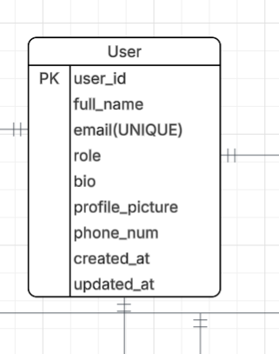

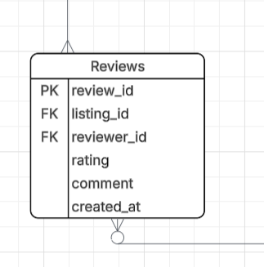
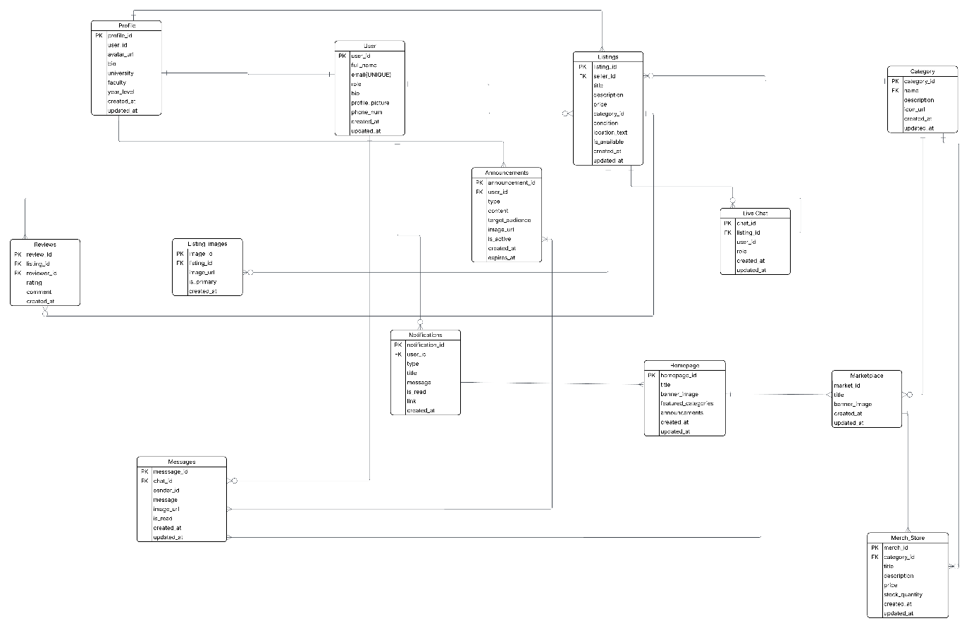

User Page Business Rules

User Registration & Authentication
- A user must register with a unique email address and username.
- A user account cannot be created without a valid password.
- Passwords must be securely encrypted before storage.
- A user can only log in if their account is active.
- A user may reset their password using email verification.
- A user can have only one profile linked to their account.
- A user role must be assigned during account creation (Student or Admin).
User Profile Management
- A user may update their profile information at any time.
- A user profile may include a profile picture, bio, university, faculty, and year level.
- A user cannot access another user’s private account settings.
- Profile updates must automatically update the updated_at field.
User Marketplace Activity
- A user can create multiple listings.
- A user can save multiple listings to favourites.
- A user can participate in multiple chats.
- A user can send multiple messages in chats.
- A user may place bids on listings if bidding is enabled.
- A user can receive multiple notifications.
- A user may purchase multiple marketplace or merch items.
User Restrictions & Validation
- A suspended or banned user cannot create listings or send messages.
- A user cannot review their own listing.
- A user must be logged in to interact with marketplace features.
- Users must comply with marketplace content policies when creating listings.
Review Page Business Rules
Review Creation
- A review can only be created after a completed order or transaction.
- A review must be linked to a valid order and listing.
- A review must have one reviewer and one reviewee.
- A user cannot submit more than one review per completed transaction.
- A review must include a rating value.
- Rating values must be between 1 and 5.
Review Content Validation
- Review comments cannot be empty if a low rating is given (1–2 stars).
- Reviews containing offensive or prohibited content may be removed by admins.
- Reviews cannot include spam, external advertisements, or false information.
- A review must contain a valid creation timestamp.
Review Permissions
- Only authenticated users may submit reviews.
- Users can only edit or delete their own reviews.
- Admins may moderate, hide, or remove inappropriate reviews.
- A review cannot be modified once the review period expires.
Review Relationships
- One user can receive many reviews.
- One user can write many reviews.
- One listing can have many reviews.
- Each review belongs to exactly one listing and one reviewer.

Review System Integrity
- Average listing ratings must automatically recalculate when reviews are added or removed.
- Deleted users’ reviews may either remain anonymized or be removed according to platform policy.
- Fake or duplicate reviews detected by the system may be flagged for moderation.
- Reviews contribute to seller reputation and trust scoring within the marketplace system.
In this essay I will be discussing my main objectives and responsibilities throughout the project which is to create the ERD, business rules and the wireframes for the Login and Review page for our student marketplace application.
I created the ERD in Lucidchart that showcased the entities, attributes, cardinalities, relationships of the ERD that are need for the database structure. I created the business rules for the login and review page, and this explained how the users will interact with the website.
I used Figma to design those wireframes. The colours that I have used for the wireframes consist of Lagoon Glass which has a RGB (103, 190, 217,), Abyssal Ledger that has a RGB (15, 23, 42) and finally the colour White which has a RGB of (255, 255, 255). I enjoyed working on these wireframes since it allowed me to be creative and because of that I found it challenging and fun. I tried to make the designs match the ideas we discussed as much as possible, I tried to make it look clean, modern and easy to use.
I am the scribe for the group’s project, and I was responsible for taking the minutes of the meetings and taking notes of the proceeding. This role is helping me improve my communication skills and organisational skills. This has helped the team stay on track with the work and stay informed about the progress within the group.
We have a repository for this assignment on Githuban d we have milestones that have been created since we need to start working on our classes for the third term so that we can have an MVP.
In conclusion this project has been rewarding and has helped me improve my skills in Figma a lot. This assignment has also helped my grow in a personal and technical manner, and I feel very confident in my abilities in terms of future projects.

The link to Figma design: https://www.figma.com/design/tULNjDqD4HvuGv11lao96q/The-groups-Wireframes-for-the-wireframes.?node-id=0-1&p=f&t=17qdOTMJVzrHe3ro-0
I did the login page and the review page and the snippets/screen shots are here on the document below:

